**Arduino Keypad DoorLock**

**Youtube Link:** [**https://www.youtube.com/watch?v=qnDZoUOrs6k**](https://www.youtube.com/watch?v=qnDZoUOrs6k)

**Arduino Libraries:-**

Keypad: <https://www.arduinolibraries.info/libraries/keypad>

Servo: <https://qafinds.com/?q=servo+h+library+arduino+download&spid=1gfc51lin5k1spc>

Password: <https://playground.arduino.cc/Code/Password/>

**Password Library:-**

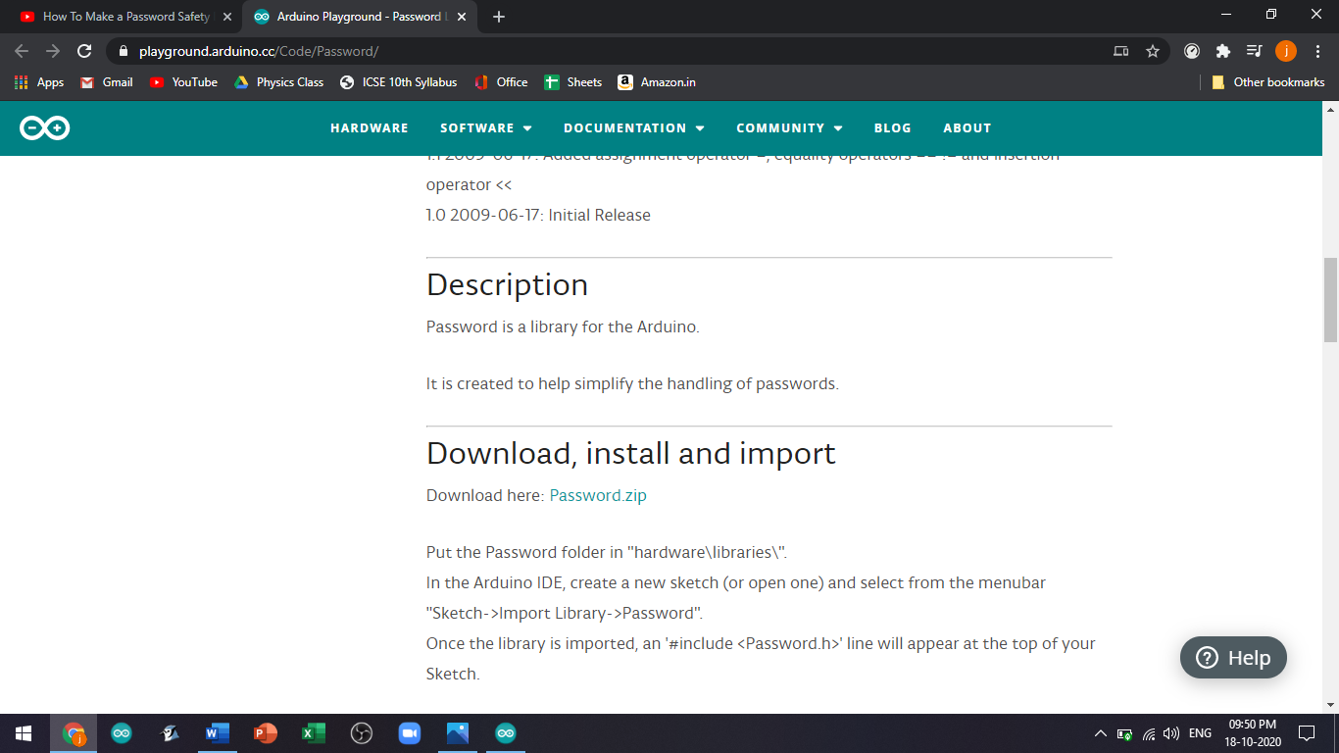

**Code:-**

#include <Password.h>

#include <Keypad.h>

#include<Servo.h>

Servo servo;

Password password = Password( "3333" );

const byte ROWS = 4;

const byte COLS = 4;

char keys[ROWS][COLS] = {

{'1','2','3','A'},

{'4','5','6','B'},

{'7','8','9','C'},

{'*','0','#','D'}

};

byte rowPins[ROWS] = { 9,8,7,6 };

byte colPins[COLS] = { 5,4,3,2, };

Keypad keypad = Keypad( makeKeymap(keys), rowPins, colPins, ROWS, COLS );

void setup(){

Serial.begin(9600);

servo.attach(11);

keypad.addEventListener(keypadEvent);

}

void loop(){

keypad.getKey();

}

void keypadEvent(KeypadEvent eKey){

switch (keypad.getState()){

case PRESSED:

Serial.print("Pressed: ");

Serial.println(eKey);

switch (eKey){

case '*': checkPassword(); break;

case '#': password.reset(); break;

default: password.append(eKey);

}

}

}

void checkPassword(){

if (password.evaluate()){

servo.write(0);

Serial.println("CORRECT OPENED");

}else{

servo.write(90);

Serial.println("WRONG CLOSED");

}

}

**Circuit Diagram:-**



